Floods
Though most parts of Rajasthan receive scanty rainfall, the State has a history of floods and inundations, mostly along the basins of rivers like Luni and Chambal. There are 13 river basins in the state viz.: Shekhawati, Ruparail, Banganga, Gambhiri, Parbati, Sabi ,Banas, Chambal, Mahi, Sabarmati, Luni, West Banas, and Sukli. Out of these, Luni, Banas, and Chambal basins are the largest and are divided into several sub basins. While the Luni river flows through parts of Ajmer, Barmer, Jalore, and Jodhpur, its sub basins of Bhund Hemawas, Sukri, Jawai and Bendi cover parts of Pali, Jalore, and Sirohi. Similarly, the Banas basin falls in Udaipur and Bundi districts and its sub basins of Berach, Morel and Mashi cover parts of Chittorgarh and Jaipur districts. Chambal is the largest basin of the State. Along with its sub basins of Kali Sindh and Parwati, it covers parts of Bundi, Kota, Jhalawar and Baran districts.
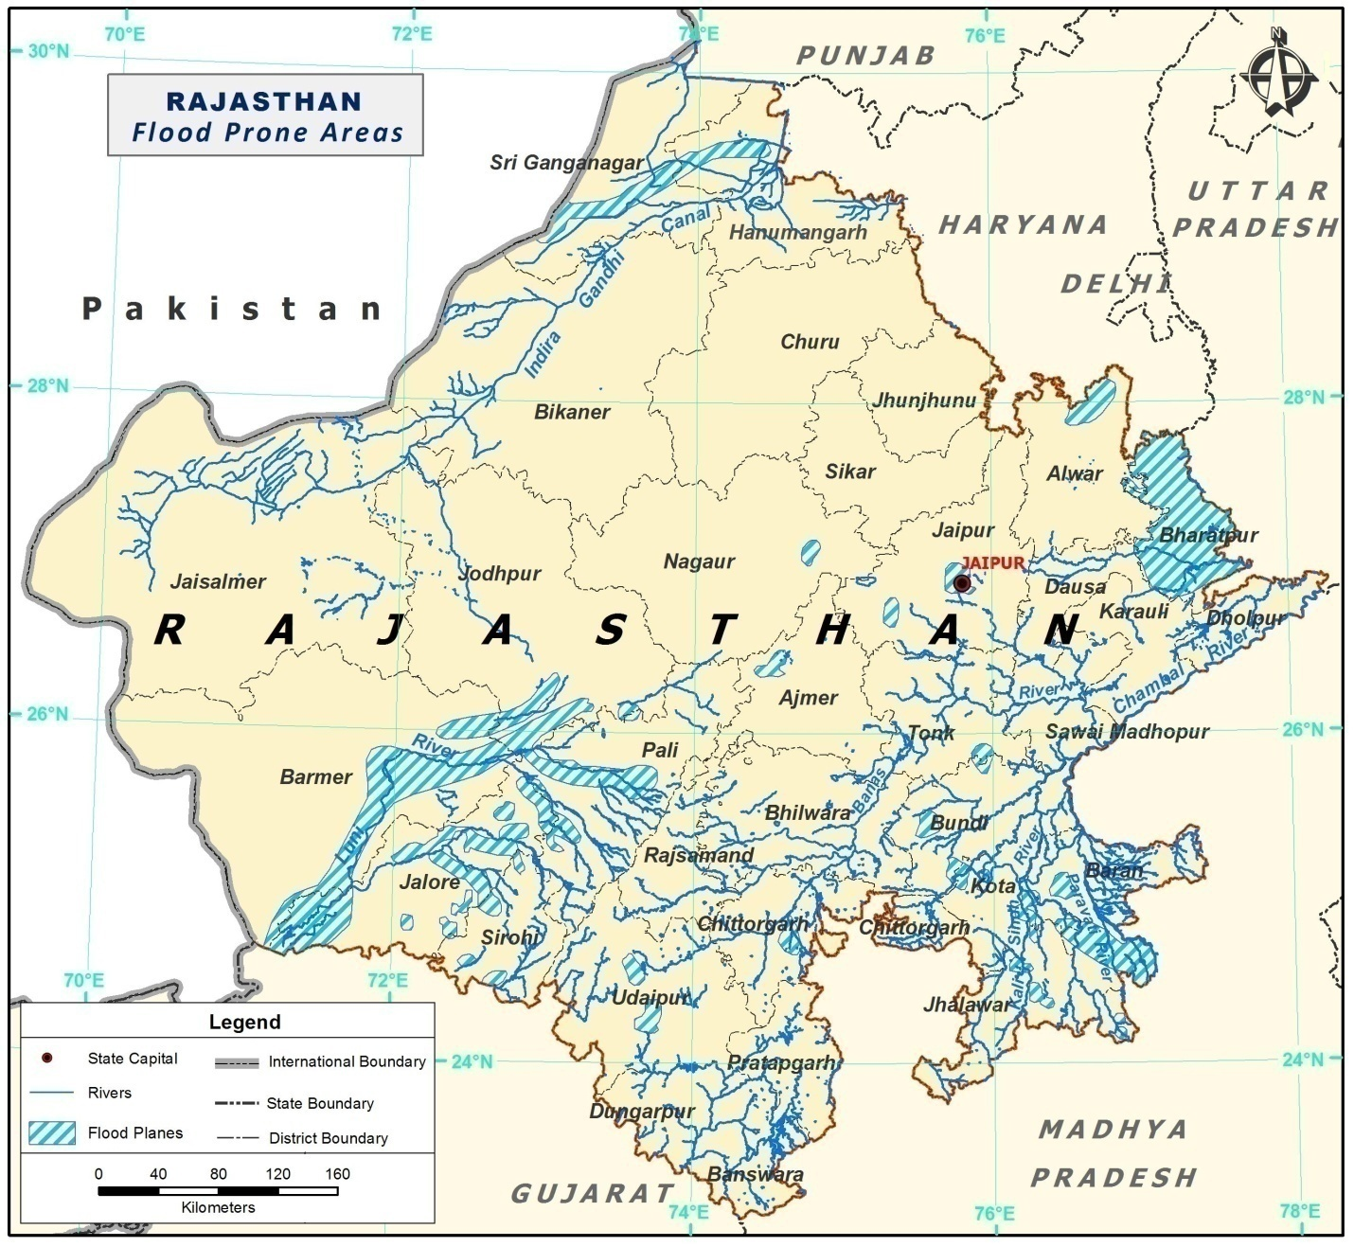
Figure 3-2: Flood prone area map; source Flood Manual, Rajasthan (Disaster Management and Relief Department)

Figure 3-2 shows the flood prone areas of Rajasthan. These include major parts of the basins and sub basins of River Luni in Barmer, Pali, Sirohi and Jalore; and the basins and sub basins of River Chambal in Baran, Kota and Bundi districts. Also, major portions of Bharatpur districts falling under the basin of River Banganga, and the basins of River Ghaggar in Sriganganagar are prone to floods.
The reasons for flooding in these regions include:
- Excess rain in the catchment
- Sudden release of large quantities of water from Dams/ water reservoirs
- Breach/ damage in major reservoirs/ dams
- Limited holding capacity
Besides the floods in these natural drainage systems, there are other reasons for inundation. Changes in rainfall patterns have also increased the risk of flash floods in many areas that were not flood prone historically. The Barmer flood in 2006 was a revelation and made disaster managers and policy makers take a fresh view of the risks and vulnerability from floods in the State. People living in the low-lying areas of the above-mentioned basins are the most vulnerable to floods.
The flood hazard of the State would be assessed comprehensively by way of analysis of flood return periods, topographic mapping and height contouring around river systems together with estimates of capacities of hydrology systems and catchment areas, analyses of precipitation records to estimate probability of overload and other scientific methods. An analysis of the flood proofing methods currently in place and their lacunae would also be carried out for identification of the flood hazard.
A composite vulnerability/ risk profile of the urban agglomerations and highly disaster prone areas would be developed.
  - Urban Flooding:
Rapid urbanisation has led to an emerging concern of urban flooding. In urban areas, flooding is primarily due to drainage failures and increased run-off loads on hard surfaces. Filling up of natural drainage channels, urban lakes, storm water drains contribute towards flooding. Besides this, poor water and sewerage management leads to outbreak of epidemics incase of flooding. For example in 1981 heavy rainfall caused flooding in Jaipur, Tonk,Nagaur and Sawai Madhopur and caused extensive damage to property and life.

